Awards:

Keys to Kindness Recognized in the Community
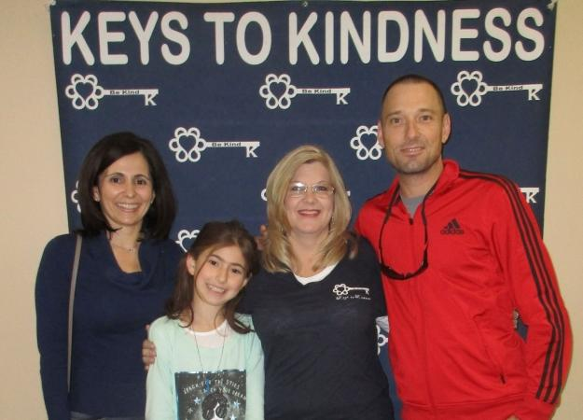
Florida Woman Helps Spread Kindness

Points of Light Award
When Sharri Cagle’s son came home on a Thursday night wanting to do something to help a fellow student who needed a heart transplant, Sharri did not hesitate to jump at the chance to help.

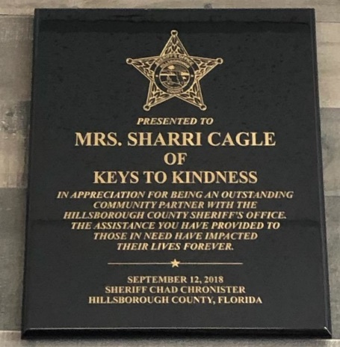

Hillsborough County Sheriff's Department Outstanding Community Partner 2018
We are proud to receive the Hillsborough County Sheriff's Department Outstanding Community Partner award for 2018!
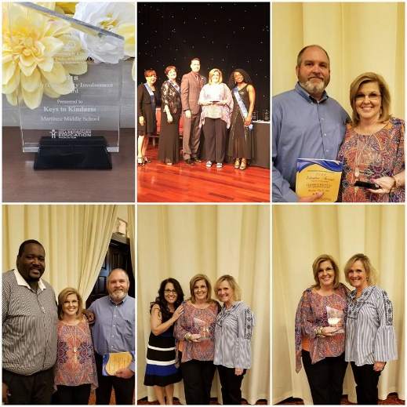
2018 Family & Community Involvement Award

Nomination from Martinez Middle School PTSA
The Keys to Kindness Project was implemented with the goal of creating an encouraging environment for our school through “Being Kind”. By creating an encouraging environment it allowed us to form partnerships with our families and community to reach this goal together..

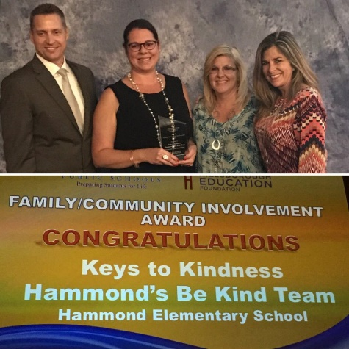
2017 Family & Community Involvement Award

Nomination from Hammond Elementary School
Keys to Kindness, Hammond’s Be Kind Team The “Being Kind” program was launched at Hammond Elementary School in 2015. Since that time students, faculty, and staff are actively engaged in activities focusing on acts of kindness. In December 2016 the school joined forces with the “Keys to Kindness” organization to place Kind Keys in various communities around the Tampa Bay Area.
2019 Daily Point of Light Award
Nomination from Natalye Paquin

Honoring individuals and groups creating meaningful change in communities across America. Awarded January 14, 2019.

Subscribe to receive Keys to Kindness News

