Our Story:
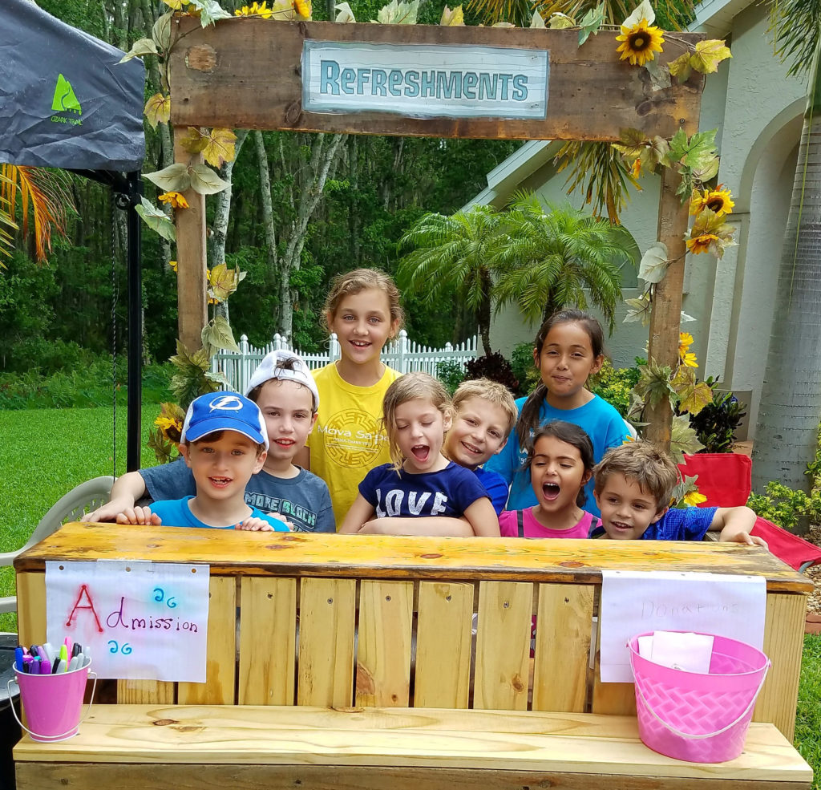
Keys to Kindness started when Sharri Cagle’s son was in 5th Grade. He came home on a Thursday from school wanting to do something to help a student in 3rd Grade that needed a heart transplant. Friday night we were building a lemonade stand to host in our neighborhood on Saturday. He rallied his classmates, friends, neighbors, and anyone that would listen to come and help with the lemonade stand. He set a goal of $200.00. A little boy, his friends, family, our community, and a whole lot of KINDNESS raised $2000.00. A child’s heart, a lemonade stand that could, and a community coming together to share kindness, seeing the impact, and knowing the need and opportunities to share a lot more kindness inspired what is now Keys to Kindness! Keys to Kindness, mission is to connect the community for kindness. Our Community Kindness Key recognizes community members sharing kindness. We facilitate and host fundraisers for various causes in the community, implement Kind Campus Programs in schools and for businesses, provide community service opportunities for our youth, Summer Kind Camp for kids, and Student Internship Program for Middle School and High School Students.
We are grateful to have our Keys to Kindness, Gifts & Gatherings Store to provide a platform for our community to come together in various ways to share kindness with others. Whether it be buying or making a gift, hosting a gathering, special event, or fundraiser, hosting monthly Kind Cause Drives, or providing opportunities for our youth; Keys to Kindness mission is To Inspire, Educate, and Empower Acts of Kindness.

Our Mission Statement:
To inspire, educate, and empower children, adults, schools, communities and businesses by providing tools and support: and to teach all that each one of us has the power, with simple acts of kindness, to be the key in changing their lives and the lives of others as well as the environment in which we live.

