Sharri Cagle
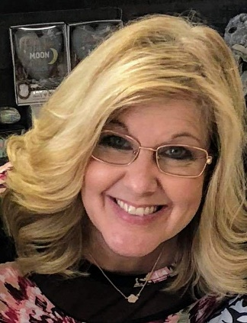
President & Founder
Sharri Cagle is a wife, mother, and Founder & President of Keys to Kindness. Sharri has a heart for helping others, building an encouraging environment, and wanting to give others a hands-on opportunity to be a part of the Keys to Kindness mission. She believes it is important to teach children that they have the power to make a difference through intentional acts of kindness; that children and adults together can make a difference! Through opportunities from working with students and staff at the YMCA as a Site Director, and an Administrative Assistant at Anza Trail School; Sharri learned how important it is to connect with others. Since her children started school she has served on the PTA at her children’s schools and continues to do so. She was Committee Chair and Den Leader for Cub Scouts and served in Girl Scouts. Sharri is also involved with the youth group at her church. Sharri’s husband and three children are her heart and right by her side kindly serving and giving back to the community they live in through Keys to Kindness.

Board Members:

Christina Melia
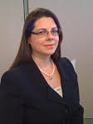
Vice President
Christina joined the LPP as a Claim Specialist in May 2001 and after serving in a supervisory position in claims, was promoted to Director of Underwriting in May 2007. She earned her RPLU designation in 2009. Christina received her law degree in 1997 and is licensed to practice in the State of Florida as well as the 11th Circuit Court of Appeals. Prior to joining the LPP she practiced as an associate attorney in the Ft. Lauderdale law firm of Doumar, Allsworth, Curtis, Cross, Laystrom, Perloff, Voigt, Wachs & MacIver. She has a broad range of litigation experience, including the professional liability area. Ms. Melia is fluent in Spanish as well as English. Christina has served on the Hammond Elementary PTA Board as Secretary for one year and President for two years as well as volunteering in the community with her daughter.

Stephanie Danforth
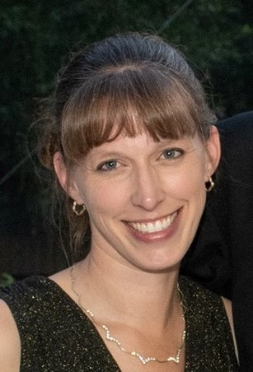
Treasurer
Stephanie the Treasurer of Keys to Kindness, and fulfills the financial responsibilities of the organization. She is a long time resident of the Bradenton/Palmetto area. Stephanie hold a Bachelors Degree from the University of South Florida, and is a Certified Pro Advisor in Quickbooks. She has volunteered and worked with a variety of non-profit groups over the years. Stephanie is a member of Evangel Baptist Church in Bradenton and currently is employed as a bookkeeper at Jim Gay CPA. In her spare time, she enjoys spending time with her husband and children.

Jenni Booth
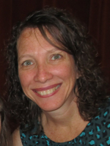
Communications Director
Jenni Booth is a graduate of the University of Central Florida. She is a proud wife and a stay-at-home mom to three amazing girls. She has a heart for giving back to others. She is active in her community through her children’s schools and church. She has also participated in programs including Meals on Wheels, Operation Christmas Child, Girl Scouts and HOWMS.

Amy Schmitzer

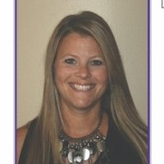
Secretary
Amy Schmitzer has been a resident of Hillsborough County for sixteen years, having relocated here from Pennsylvania. My background is in Real Estate and operations, and am a licensed real estate agent serving the Tampa Bay and beach areas. My favorite part about my job is I get to spend my days with wonderful clients helping them find their forever home. I have served on the PTA board for 3 years now. My children’s sports and school activities keep me active in the community. My wonderful husband and kids love to be outdoors, camping and entertaining family and friends. I am a wife, mom, sister, aunt, daughter, who has a HUGE love of Jesus, wanting to do my best and make a difference in someone else’s life. My personal philosophy is, life has given me much ~ and so, I have much to share and give forward.

Kind Crew:

Colin Cagle
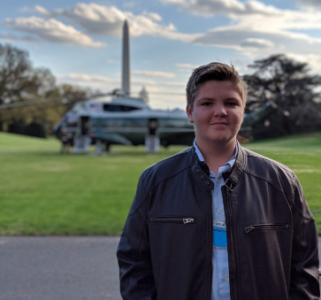
Social Media
Colin is the inspiration behind Keys to Kindness. His compassion for others and wanting to help another student in need helped Keys to Kindness come to fruition. Colin is a Freshman in High School with straight A’s. He is a Boy Scout working on his Eagle requirements. He is involved in NJHS, Student Ambassadors, and loves working with kids with special needs. He is extremely thoughtful and wants to help others. He has volunteered on many projects for Keys to Kindness and other community organizations. Colin loves the community outreach and people he gets to meet through Keys to Kindness. His time helping with Keys to Kindness Social Media helps us greatly.

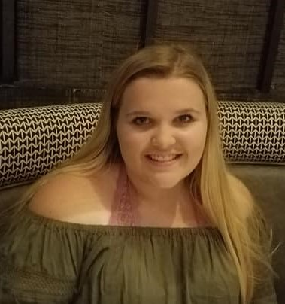
Lindsey Cagle
Customer Service Consultant
Lindsey is a freshman in college. She is deciding whether or not to pursue a career in engineering or medicine. She is extremely smart and has a heart of gold. She has a special love for kids and the elderly. Lindsey sees a need and wants to help fill it. She has such loyalty and love for her family. Lindsey helped set up Keys to Kindness, Gifts & Gatherings from the ground up as well as organize and lead Kind Camp for the past two years. She volunteers her time at Keys to Kindness, Gifts & Gatherings each week to help with customers and planning events. Lindsey loves connecting with the people she gets to meet and likes being able to be involved in helping with our community kind causes.

Susan Terzuoli
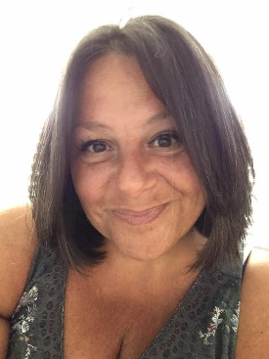
Store Operations
Sue is a former New Yorker in the Tampa Bay Area for almost six years now. One day at the nail salon she met Sharri Founder of Keys to Kindness, and she said that day changed her life. She said she was looking for something to not only fill her time but feed her soul. K2K became that place for her. Daily interactions with customers and being involved with the community with various fundraisers, spreading and promoting kindness are just a few of things she loves doing with K2K. In her spare time, she loves being with her family, cooking, traveling, and going to concerts. Sue is a people person and making a difference!

Stephanie Raine
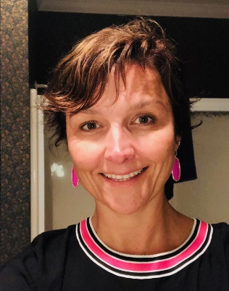
Customer Service Consultant
Stephanie is happily married to her husband & says she has the greatest privilege of being “Mom” to their beautiful 13 yo daughter and their four-legged son. She enjoys most any type of art, doing anything creative and has a whole room in her home dedicated to such! She loves to decorate, to give gifts (esp homemade ones) and to make things beautiful. Stephanie believes that God gave her a pretty big heart made to help and love on others. When she met Sharri -Founder of Keys to Kindness at the store’s grand opening, she said she just knew she was meant to be a part of her mission to make the world a better place, one act of kindness at a time. Stephanie is doing just that!
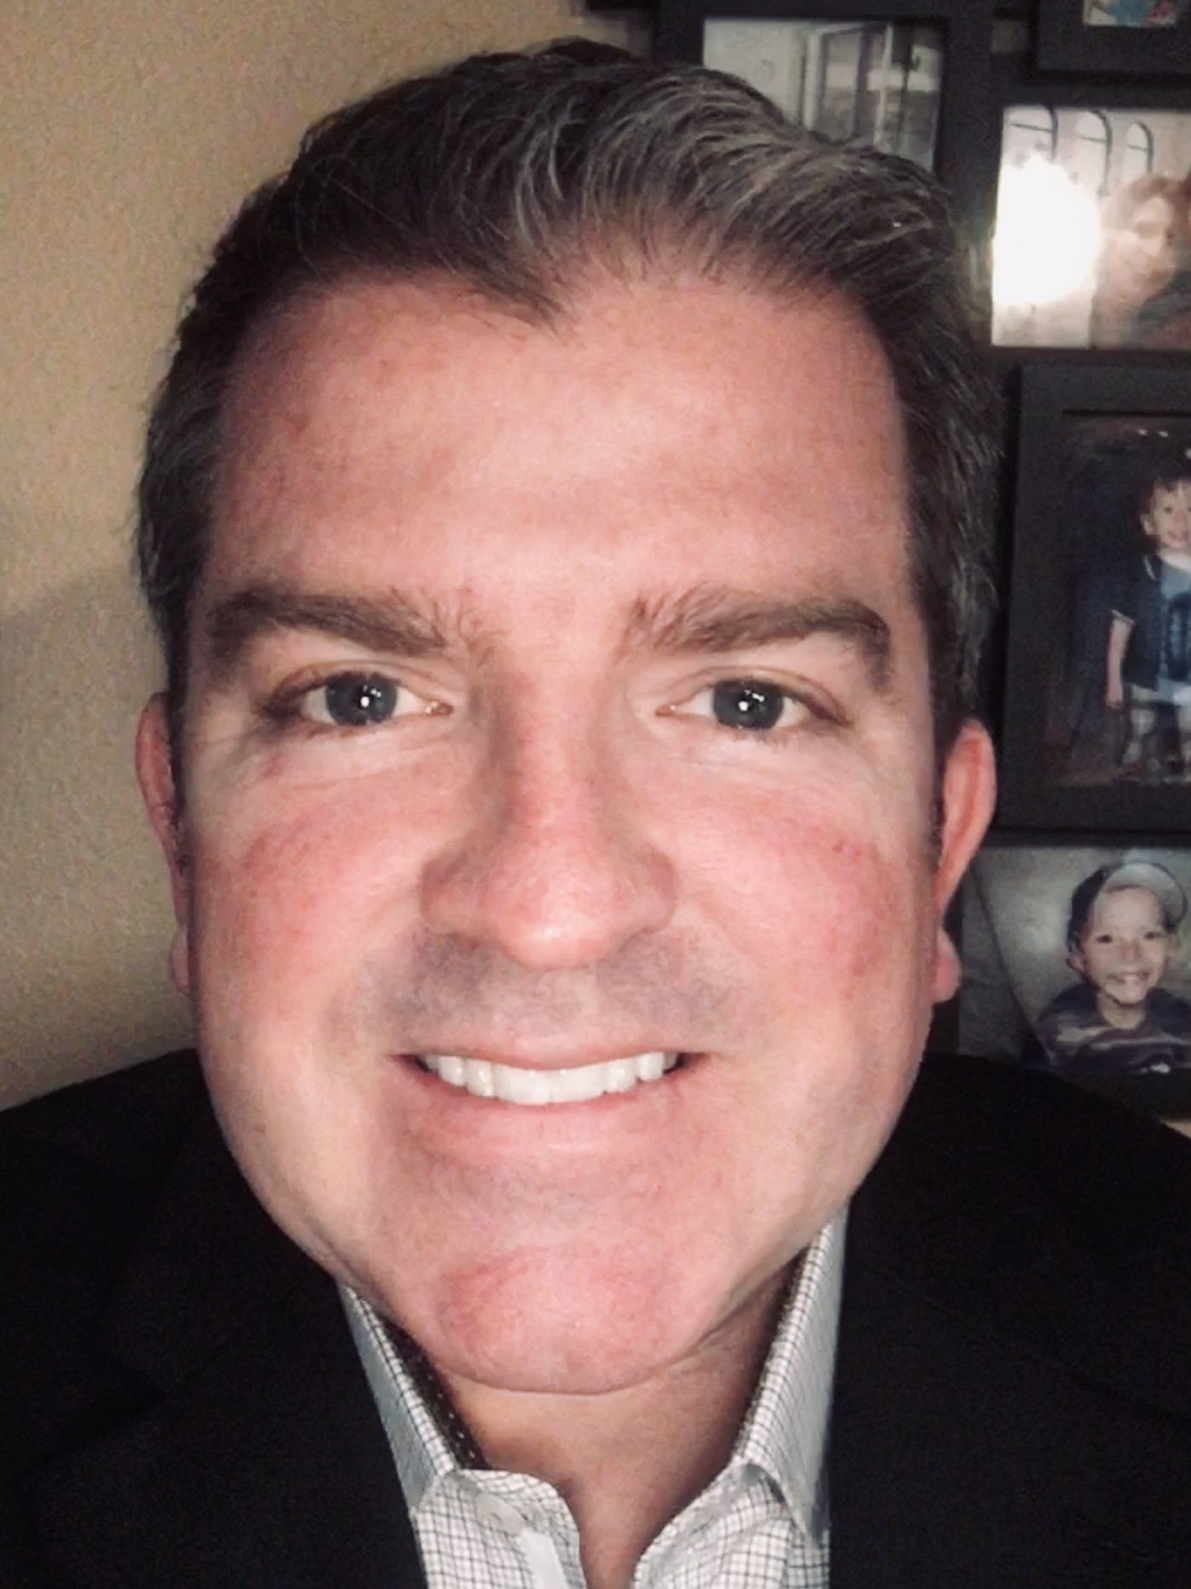

Keith Gilkes
Community Enrichment Director
Keith Gilkes is a resident of Hillsborough County in Lutz, Florida with his wife, Rosario, and two children, Conner and Cristian. An avid golfer and graduate from the University of Tampa, Keith enjoys hosting fundraising events for special needs children and many other community enrichment programs. Keith has close ties to local schools and several ESE Programs supporting children on the Autism Spectrum as well as other mental and physical handicaps. Several of the fundraising events he hosted with his wife, Rosario, produced augmented reality learning environments, handicap and ESE accessible playgrounds, sensory-specific technology, and many other products specifically designed to help special needs students thrive. Keith has a life mission to put smiles on the faces of special needs children and give voices to the voiceless. Keith has been in the electronics distribution industry for over 20 years in supply chain and operations capacities as well as the digital dentistry and medical manufacturing industries. As a member of the Keys to Kindness Crew, Keith will strive to spread community kindness in any way possible and is honored to be a part of this special organization!

